Case Study: Healthcare Data Platform using Azure Synapse
Business Scenario
A hospital chain wants to build a centralized data platform to:
- Track patient records
- Monitor ICU and emergency cases in real-time
- Analyze disease trends
- Optimize hospital operations

Architecture Overview
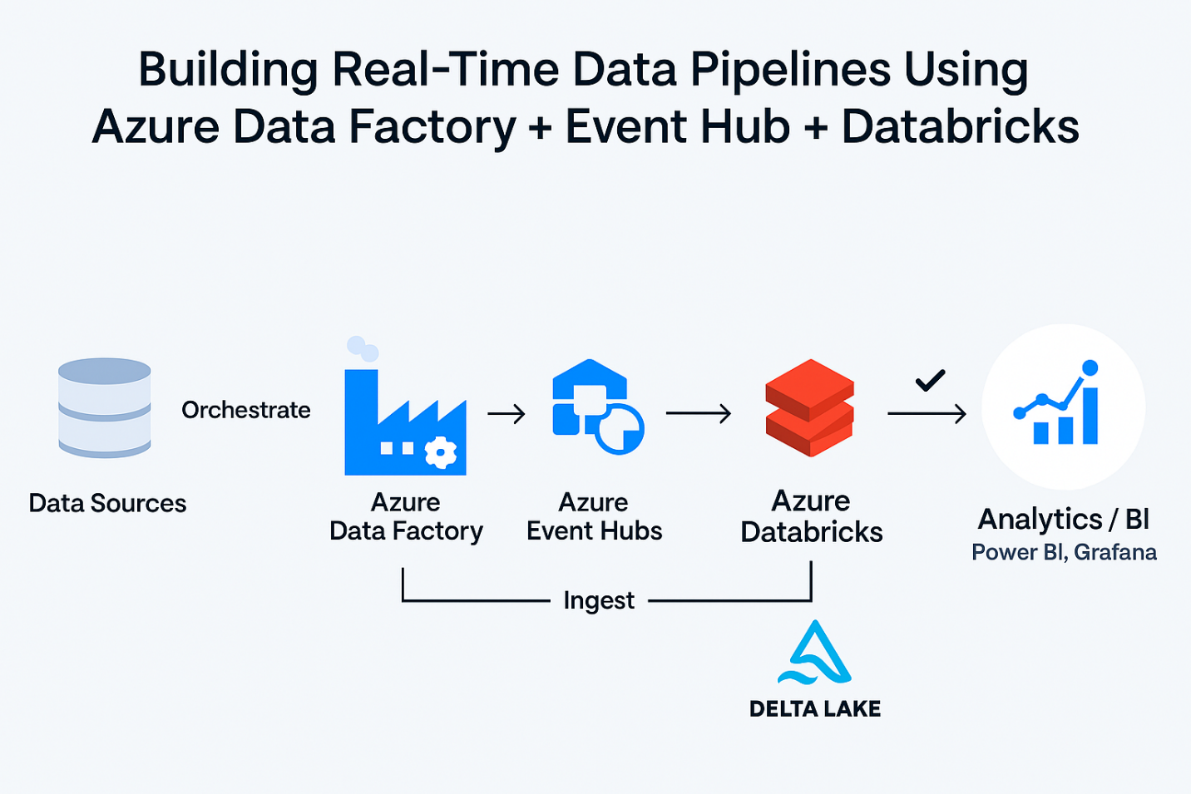
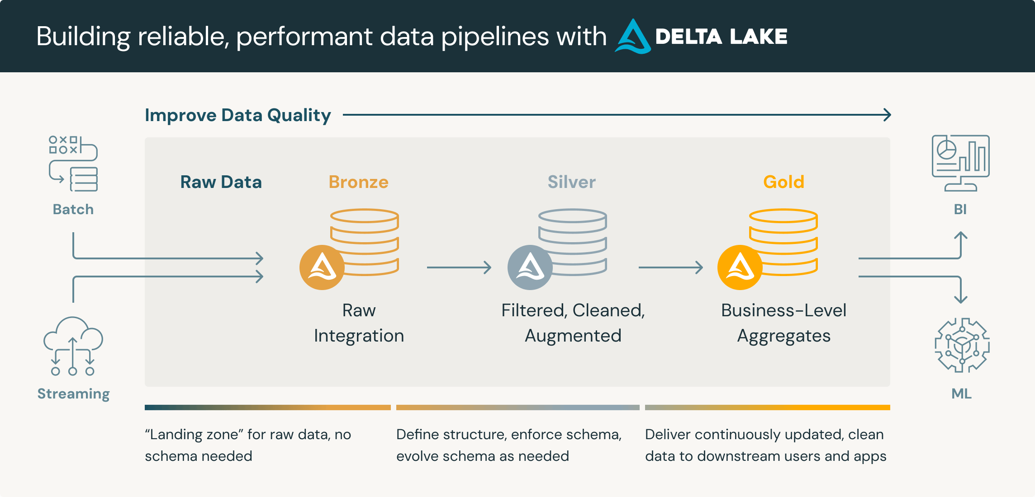

Components Used:
- ADLS Gen2 → Storage (Raw + Processed)
- Synapse Pipelines → Data ingestion
- Synapse SQL / Spark → Processing
- Event Hub → Real-time ICU streaming
- Power BI → Dashboard

Data Sources
Batch Data
- Patient records (CSV from hospital systems)
- Doctor schedules
- Billing data
Streaming Data
- ICU devices (heart rate, oxygen levels)
- Emergency alerts
Step-by-Step Implementation

Step 1: Create Folder Structure in ADLS
Design Medallion Architecture:
/healthcare-data/
/bronze/ → raw data
/silver/ → cleaned data
/gold/ → analytics-ready
Example:
/bronze/patients/
/silver/patients_clean/
/gold/patient_summary/

Step 2: Ingest Batch Data (Using Synapse Pipelines)
Go to Ingest → New Pipeline
Pipeline: PL_Load_Patient_Data
Activity: Copy Data
- Source: CSV (hospital system)
- Sink: ADLS /bronze/patients/
Configuration:
Setting | Value
Source | Blob / File
Sink | ADLS Gen2
Format | CSV

Step 3: Data Cleaning using Spark Notebook
Go to Develop → Notebook
Notebook: NB_Clean_Patient_Data
df = spark.read.csv('/bronze/patients/', header=True)
# Remove nulls
df_clean = df.dropna()
# Convert data types
from pyspark.sql.functions import col
df_clean = df_clean.withColumn("age", col("age").cast("int"))
# Save to Silver
df_clean.write.mode("overwrite").parquet('/silver/patients_clean/')

Step 4: Create SQL External Table (Serverless SQL)
Go to Develop → SQL Script
CREATE EXTERNAL TABLE patients_clean
WITH (
LOCATION = '/silver/patients_clean/',
DATA_SOURCE = healthcare_ds,
FILE_FORMAT = parquet_format
)
AS SELECT * FROM OPENROWSET(
BULK '/silver/patients_clean/',
DATA_SOURCE = 'healthcare_ds',
FORMAT='PARQUET'
) AS rows;

Step 5: Data Transformation (Gold Layer)
Create analytics-ready dataset:
SELECT
disease,
COUNT(*) AS patient_count,
AVG(age) AS avg_age
FROM patients_clean
GROUP BY disease;
Store result in /gold/patient_summary/

Step 6: Real-Time Streaming (ICU Monitoring)
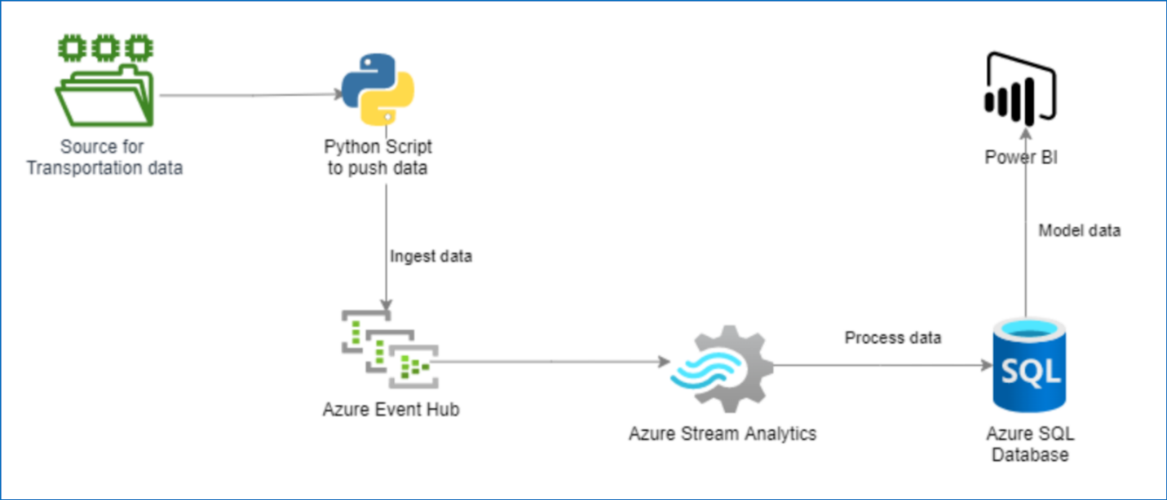

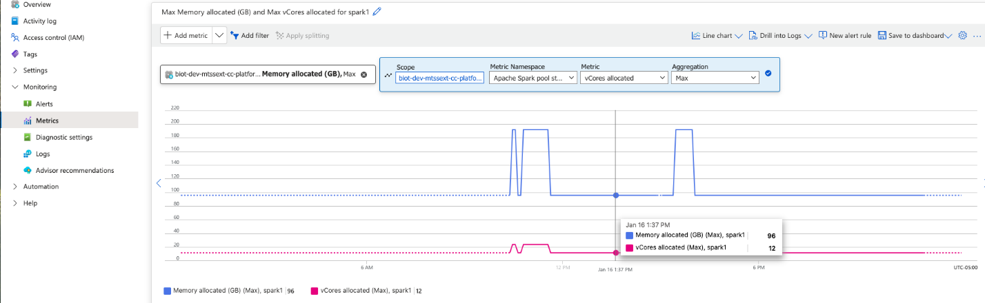
Flow:
ICU Devices → Event Hub → Stream Analytics → ADLS → Synapse
Stream Analytics Query:
SELECT
deviceId,
AVG(heartRate) AS avg_hr,
System.Timestamp AS window_time
INTO output
FROM input TIMESTAMP BY eventTime
GROUP BY deviceId, TumblingWindow(minute, 1)

Step 7: Orchestration Pipeline
Create pipeline:
PL_Healthcare_EndToEnd
Steps:
- Copy Data (Bronze)
- Execute Notebook (Silver)
- Run SQL Script (Gold)
Add Trigger → Daily schedule

Step 8: Monitoring
Go to Monitor Tab
Track:
- Pipeline runs
- Failures
- Data latency

Step 9: Visualization (Power BI)
Connect Power BI to:
- Synapse SQL endpoint
- Gold layer tables
Dashboards:
- Patient count by disease
- ICU alerts
- Hospital occupancy
- Daily admissions

Key Insights Generated
- Top diseases by region
- ICU utilization trends
- Average recovery time
- Emergency spike detection

Summary Flow
Batch Data → Pipeline → ADLS Bronze
↓
Spark (Clean)
↓
Silver Layer
↓
SQL Aggregation
↓
Gold Layer
↓
Power BI
Streaming → Event Hub → Stream Analytics → ADLS → Synapse

